**Improved Stability in Organic Light-Emitting Devices by Mixing Ambipolar and Wide Energy Gap Hosts**

John S. Bangsunda†, Kyle W. Hersheya†, Dominea C. K. Rathwellb, Hong-Yeop Nab, Jeong-Hwan Jeonb, Peter Trefonasc, and Russell J. Holmesa

aDepartment of Chemical Engineering and Materials Science, University of Minnesota, Minneapolis, Minnesota, 55455, USA

bDow Seoul Technology Center, Hwaseong, Gyeonggi-Do 18449, Korea

cThe Dow Chemical Company, Marlborough, MA 01752, USA

†These authors contributed equally to this work

**Abstract**

Improved operation stability is realized in phosphorescent organic light-emitting devices (OLEDs) by adding a wide energy gap host material to an already ambipolar emissive layer. While the resulting structure contains two host materials, this device differs from more conventional mixed-host OLEDs that combine hole- and electron-transporting hosts. Here, charges are transported primarily along the ambipolar host and the emitter, and the addition of the wide energy gap host serves to tune the charge injection and transport characteristics of the emissive layer. This approach offers fine control over the exciton recombination zone width and position. By decoupling overall device degradation into the photostability of the emitter and the exciton formation efficiency, the detailed role of the wide energy gap host in improving performance is elucidated. Unlike conventional mixed-host OLEDs, where mixing tends to increase recombination zone width and overall stability, mixing in this system reduces the extent of the recombination zone while improving stability. This enhancement is explained in terms of a trade-off between bulk and interfacial degradation, with the recombination zone being pushed away from an interface, reducing the overall width but improving stability. We find that the lifetime can be improved by 50% by balancing this observed trade-off between bulk and interfacial degradation.

Several studies of operational stability in organic light-emitting devices (OLEDs) have suggested that exciton density-driven processes are responsible for overall device degradation.1–5 Consequently, substantial work has sought to reduce exciton density in the OLED emissive layer by engineering the exciton recombination zone (RZ). The RZ is the spatial extent of exciton formation in an OLED, and its width determines the exciton density for a given luminance, setting the rate of emissive layer degradation.2,6 Previous studies have found that device lifetime can be enhanced by maximizing the RZ width.2,6–8 In conventional mixed- and graded-emissive layer (EML) devices, electron- and hole-transporting hosts are mixed to achieve high charge balance and a wide RZ.7,9–13 The absolute position of the RZ is also important, as proximity to a transport layer interface can exacerbate degradation,14–17 or influence exciton confinement and charge balance.17–19 In cases showing interfacial degradation, the RZ is typically pinned at the degrading interface. Avoiding both bulk and interface degradation suggests a trade-off between increased RZ width for reduced exciton density and the need to avoid stressing unstable interfaces.

In this work, we demonstrate an unconventional mixed-EML approach to improve device stability that combines an ambipolar charge-transporting host with a wide-energy gap host. Varying the EML composition permits tuning of the exciton RZ width and position, and an optimization of device stability. This system illustrates a trade-off between bulk and interfacial degradation as lifetime is not optimized for devices with the broadest RZ width, in contrast to conventional mixed-EML OLEDs.20–22 It is further interesting to note that the stability of an ambipolar host material can be enhanced through the addition of a wide-energy gap host which modulates charge transport and the RZ in the EML.

Here, devices are constructed using two proprietary host materials, designated Host A and Host B, and provided by The Dow Chemical Company. For commercial devices manufactured by The Dow Chemical Company, devices constructed using a uniform mixture of these hosts yield improved lifetimes up to $t_{90}$ =8.6 hrs at 15,000 cd/m2 compared to $t_{90}$ =1.3 hrs and $t_{90}$ =4.2 hrs for Hosts A and B, respectively, where $t_{90}$ is the time to degrade to 90% of the initial luminance. It is worth noting that these lifetimes are reported at an extreme luminance condition used for rapid commercial screening of stable OLEDs. Devices with an active area of 25 mm2 were fabricated on glass substrates pre-patterned with a 150-nm-thick anode layer of indium tin oxide (ITO, Xinyan). Substrates were cleaned with solvents and ambient UV-ozone. A hole-injection layer of poly(thiophene-3-[2[(2-methoxyethoxy)ethoxy]-2,5-diyl) (AQ1250, Sigma Aldrich) was spin-cast on the ITO anode, followed by a hole-transport layer (HTL) of 4,4',4"-tris(*N*-carbazolyl)triphenylamine (TCTA, TCI America). The emissive layer (EML) consists of Host A, Host B, or a mixture of the two hosts, and a constant emitter loading of 15 vol.% *fac*-tris(2-phenylpyridine)iridium(III) (Ir(ppy)3 (Lumtec). Mixture compositions of 0%, 5%, 15%, 30%, 50%, 70%, 85%, and 100% Host B by volume were considered in devices. An electron-transport layer (ETL) of tris-(1-phenyl-1H-benzimidazole) (TPBi, Lumtec) is deposited over the EML, followed by a 0.5 nm LiF/ 100 nm Al cathode. The HIL is spin-cast in a N2 glovebox and annealed for 30 minutes at 150°C. The remaining layers are deposited by vacuum thermal evaporation at a base pressure <7×10-7 Torr and a rate of 0.3 nm/s. Devices are encapsulated with epoxy and a cover glass in a N2 glovebox. Efficiency and luminance measurements were taken with an Agilent 4155C parameter analyzer and a large area photodiode (Hamamatsu S3584–08), assuming Lambertian emission for luminance calculations. Electroluminescence (EL) spectra were collected with an Ocean Optics HR4000 spectrometer. Device lifetimes were characterized at 5000 cd/m2 using a Keithley 26XX to source device current and to measure device EL from a Hamamatsu S2281 photodiode. Photoluminescence (PL) was measured periodically during degradation by temporarily disabling current to the device and optically pumping the device using a λ=473 nm laser (Coherent OBIS). This method has been previously described and has been shown not to further degrade devices or influence the electrical lifetime.16

Figure 1a shows the molecular orbital energy levels for the active materials of interest. The highest occupied molecular orbital (HOMO) energy levels for Host A and Host B are calculated using density functional theory (Gaussian, Basis set: B3LYP / 6-31g(d)), lowest unoccupied molecular orbital (LUMO) levels are estimated by adding the optical energy gap measured using ellipsometry to calculated HOMO levels (*Eg* = 3.4 eV for Host A and *Eg* = 2.9 eV for Host B), and triplet energies are obtained from low temperature phosphorescence.23–26 The measurement of these parameters is discussed further in the Supplementary Material. Energy levels for the remaining materials are obtained from literature.27–30 Despite having differences in energy gap and fluorescence energy, Host A and Host B have similar triplet energies. It is worth noting that the energy levels of Host B reside entirely within those of Host A, and Host A and B do not form an emissive exciplex, as confirmed from measurements of PL on a mixed film and from EL on a simple bilayer device (ITO/Host A/Host B/LiF/Al).

The dependence of the external quantum efficiency on EML composition is shown in Fig. 1b-c. Devices containing <30% Host B show a reduced efficiency, with the remaining mixed-EML devices exhibiting efficiencies between 18% and 19%. The turn-on voltage to achieve 1 cd/m2, shown in Fig. 1c, is reduced by >1 V when increasing the Host B concentration from 0 to 30%, before plateauing. This behavior is attributed to an improvement in the efficiency of charge injection and transport upon adding Host B to the EML, likely reflecting a difference in molecular orbitals energy levels.

Figure 2 shows the dependence of device lifetime on EML composition, with mixed architectures showing superior stability to those based on an EML of pure A or B. Interestingly, the stability of devices based on Host B ($t_{80}=(40±2$) hours) is improved upon adding Host A ($t_{80}=(59±2$) hours for 50% B device), despite devices based on a pure EML of Host A showing a short lifetime ( $t_{80}=7$ hours). In contrast, the PL stability is highest for devices with 100% Host B ($t_{95}=(48±10$) hours), with mixtures showing shorter PL lifetimes (Fig. 2b). In previous work, PL stability has been found to scale with exciton density, with devices having the widest RZ showing the highest PL stability.2 Here, this would suggest that the RZ is widest in devices based on pure Host B, yet that the overall EL lifetime is not optimized by maximizing RZ width. This trend could result from a trade-off between bulk degradation within the EML, and degradation at an interface adjacent to the EML.14–16 In order to probe this hypothesis, the RZ extent is measured directly.

The RZ for devices containing 0%, 50%, and 100% Host B were measured using a $δ$-doped sensitizer approach.31 Discontinuous layers (nominally 0.1 nm thick) of the near-infrared phosphor Pt (II) tetraphenyltetrabenzoporphyrin (PtTPTBP) were deposited at various locations in the EML. Sensitizer molecules in these discontinuous strips are spaced to avoid significant concentration quenching and limit the impact of the strip on the electrical properties of the device. The exciton population residing on Ir(ppy)3 in the region within a Förster radius (±4 nm) of these strips is quenched, leading to emission from PtTPTBP. The ratio of the EL from Ir(ppy)­3 between the sensitized and control devices (denoted $β$) reflects the fraction of electrically generated excitons which recombine on Ir(ppy)3. Therefore, ($1-β$) reflects the local exciton density within a Förster radius of the sensitizer strip.32 By translating this sensitized strip across the emissive layer, the change in EL can be compared to yield the spatial exciton profile in the EML. This measurement is found to agree within error with recombination zone characterization based off of an out-coupling corrected sensitizer emission approach.2,18,33 The area-normalized exciton population map resulting from this measurement for each architecture is shown in Fig. 3a, with the associated EL spectra included in the Supplementary Material. Host A is shown to have the highest exciton density of all three architectures, peaked at the ETL interface. Host B has the widest recombination zone, with a nearly flat exciton density across the EML. The 50% Host B mixture shows an intermediate behavior with a narrower RZ than Host B that is also shifted away from the HTL/EML interface. The observed increase in stability of the mixture, despite its reduced RZ width again suggests the HTL/EML interface plays a role in the degradation of wide RZ devices based on an emissive layer of Host B.

The shift in RZ width and position can be understood by considering how the addition of Host A to the EML changes injection and charge transport in the EML. Both injection and transport are assessed in single-carrier devices fabricated for compositions of 0%, 50%, and 100% Host B. The layer structure for electron-only devices (EOD) is ITO (150 nm)/Al (10 nm)/LiF (1 nm)/TPBi (20 nm)/EML (100 nm)/TPBi (20 nm)/LiF (1 nm)/Al (100 nm). The layer structure for hole-only devices (HOD) is ITO (150 nm)/AQ1250 (70 nm)/TCTA (20 nm)/EML (100 nm)/TCTA (20 nm)/MoOx (10 nm)/Al (100 nm). All emissive layers were doped with 15 vol. % Ir(ppy)3. The current-voltage characteristics for HOD and EOD are shown in Fig. 3b-c. In both cases, devices based on Host B show larger currents than those based on Host A. The addition of Host A to Host B reduces both the hole- and electron-currents, suggesting Host B and the phosphorescent guest remain the dominant transporting phase, even in mixtures. Thus, the observed shift in device stability and RZ position reflect a favorable adjustment in the transport properties of the EML upon adding Host A.

To further confirm that the lifetime enhancement upon mixing is driven by reduced interfacial degradation and not differences in intrinsic or morphological stability of the EML, devices were fabricated with a 10-nm-thick EML. With a thin emissive layer, excitons are present throughout the entire EML, minimizing variations in RZ position and width between different devices and equalizing the role of degradation at the HTL/EML interface. For these devices, the ETL thickness is increased to 50 nm to center the electric field profile of the λ=473 nm pump laser in the EML (Fig. S3). All other layers have the same thicknesses as the 40-nm-thick EML devices. The peak external quantum efficiency of these devices was found to be (14 ± 1)% for all three EML architectures (Fig. S4). The EL and PL lifetimes are shown in Figs. 4a and 4b, respectively. Devices containing 50% and 100% Host B are found to have identical lifetimes with $t_{50}$ = (22 ± 1) hr for EL, and $t_{80}$ = (16 ± 1) hr for PL. This behavior suggests that the intrinsic and/or morphological stability is the same for devices based on Host B and the 1:1 mixture, providing further evidence that stability differences for the 40-nm-thick EML devices stem from differences in RZ position. Host A still shows a shorter lifetime in both EL and PL, likely due to its narrow RZ which is heavily peaked at the ETL interface.

In this work, enhanced lifetime is demonstrated in an unconventional mixed-host architecture employing a wide energy gap host and an ambipolar host. Based on measurements of the exciton RZ, the wide energy gap host serves to frustrate electron injection and transport in the emissive layer, allowing the position and width of the recombination zone to be controlled. Notably, lifetime is improved upon mixing despite a reduction in both recombination zone width and PL stability. The overall increase in stability is shown to result from shifting the RZ away from an unstable interface. This work provides a design tool to manage the position of the recombination zone, allowing the trade-off between bulk and interfacial degradation to be balanced to optimize lifetime

**Acknowledgments**

Funding and support for this work was provided by The Dow Chemical Company. J.S.B. acknowledges support from the National Science Foundation Graduate Research Fellowship under Grant No. 00039202. R.J.H. is a member of the Dow Chemical Company Technical Advisory Board.

**References**

1 N.C. Giebink, B.W. D’Andrade, M.S. Weaver, P.B. MacKenzie, J.J. Brown, M.E. Thompson, and S.R. Forrest, J. Appl. Phys. **103**, (2008).

2 J.S. Bangsund, K.W. Hershey, and R.J. Holmes, ACS Appl. Mater. Interfaces acsami.7b16643 (2018).

3 D.Y. Kondakov, in edited by F. So (CRC Press, Boca Raton, FL, 2010), pp. 211–242.

4 S. Schmidbauer, A. Hohenleutner, and B. König, Adv. Mater. **25**, 2114 (2013).

5 S. Scholz, D. Kondakov, B. Lüssem, and K. Leo, Chem. Rev. **115**, 8449 (2015).

6 Y. Zhang, J. Lee, and S.R. Forrest, Nat. Commun. **5**, 1 (2014).

7 A.B. Chwang, R.C. Kwong, and J.J. Brown, Appl. Phys. Lett. **80**, 725 (2002).

8 Z. Wu, N. Sun, L. Zhu, H. Sun, J. Wang, D. Yang, X. Qiao, J. Chen, S.M. Alshehri, T. Ahamad, and D. Ma, ACS Appl. Mater. Interfaces **8**, 3150 (2016).

9 N.C. Erickson and R.J. Holmes, J. Appl. Phys. **110**, 084515 (2011).

10 S. Lee, H. Koo, O. Kwon, Y.J. Park, H. Choi, K. Lee, B. Ahn, and Y.M. Park, Sci. Rep. **7**, 11995 (2017).

11 J.-H. Lee, C.-I. Wu, S.-W. Liu, C.-A. Huang, and Y. Chang, Appl. Phys. Lett. **86**, 103506 (2005).

12 C.-H.C.-C. Hsiao, Y.-H. Chen, T.-C. Lin, C.-H.C.-C. Hsiao, and J.-H. Lee, Appl. Phys. Lett. **89**, 163511 (2006).

13 W. Song, J.Y. Lee, Y.J. Cho, H. Yu, H. Aziz, and K.M. Lee, Adv. Sci. **5**, 1700608 (n.d.).

14 Q. Wang, B. Sun, and H. Aziz, Adv. Funct. Mater. **24**, 2975 (2014).

15 Q. Wang and H. Aziz, ACS Appl. Mater. Interfaces **5**, 8733 (2013).

16 K.W. Hershey, J. Suddard-Bangsund, G. Qian, and R.J. Holmes, Appl. Phys. Lett. **111**, 113301 (2017).

17 S.K. Jeon and J.Y. Lee, Org. Electron. Physics, Mater. Appl. **27**, 202 (2015).

18 C. Coburn, J. Lee, and S.R. Forrest, Adv. Opt. Mater. **4**, 889 (2016).

19 C. Coburn and S.R. Forrest, Phys. Rev. Appl. **7**, 041002 (2017).

20 J.-M. Kim, C.-H. Lee, and J.-J. Kim, Appl. Phys. Lett. **111**, 203301 (2017).

21 H. Shin, S. Lee, K.-H. Kim, C.-K. Moon, S.-J. Yoo, J.-H. Lee, and J.-J. Kim, Adv. Mater. **26**, 4730 (2014).

22 Y. Yamada, H. Inoue, S. Mitsumori, T. Watabe, T. Ishisone, T. Hara, T. Takahashi, H. Nakashima, and S. Seo, SID Symp. Dig. Tech. Pap. **47**, 711 (2016).

23 N. Turro, J.C. Scaiano, and V. Ramamurthy, *Modern Molecular Photochemistry of Organic Molecules* (University Science Books, 1991).

24 K. Goushi, R. Kwong, J.J. Brown, H. Sasabe, and C. Adachi, J. Appl. Phys. **95**, 7798 (2004).

25 K. Goushi, Y. Kawamura, H. Sasabe, and C. Adachi, Japanese J. Appl. Physics, Part 2 Lett. **43**, 0 (2004).

26 A. Volcker, Chem. Phys. Lett. **159**, 103 (1989).

27 S.E. Shaheen, G.E. Jabbour, M.M. Morrell, Y. Kawabe, B. Kippelen, N. Peyghambarian, M.-F. Nabor, R. Schlaf, E.A. Mash, and N.R. Armstrong, J. Appl. Phys. **84**, 2324 (1998).

28 S. Reineke, F. Lindner, G. Schwartz, N. Seidler, K. Walzer, B. Lüssem, and K. Leo, Nature **459**, 234 (2009).

29 J. Ding, Q. Wang, L. Zhao, D. Ma, L. Wang, X. Jing, and F. Wang, J. Mater. Chem. **20**, 8126 (2010).

30 S.C. Lo, N.A.H. Male, J.P.J. Markham, S.W. Magennis, P.L. Burn, O. V. Salata, and I.D.W. Samuel, Adv. Mater. **14**, 975 (2002).

31 B. Sim, C.-K. Moon, K.-H. Kim, and J.-J. Kim, ACS Appl. Mater. Interfaces **8**, 33010 (2016).

32 N.C. Erickson and R.J. Holmes, Adv. Funct. Mater. **24**, 6074 (2014).

33 J. Lee, C. Jeong, T. Batagoda, C. Coburn, M.E. Thompson, and S.R. Forrest, Nat. Commun. **8**, 15566 (2017).

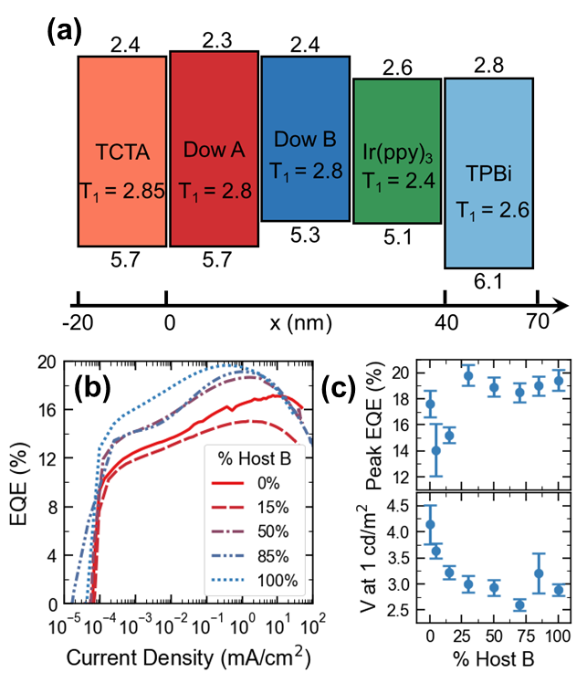

**Figure 1.** (a) Energy level schematic illustrating the HOMO, LUMO, and triplet energy levels for the materials used in this study. The x-axis denotes the layer thicknesses used in the devices of interest, as a function of distance from the HTL/EML interface. (b) External quantum efficiency (EQE) as a function of current density for various Host A and Host B blend ratios. (c) Peak EQE and turn-on voltage (at 1 cd/m2) as a function of host composition. Error bars represent standard deviations taken over at least four separate pixels.

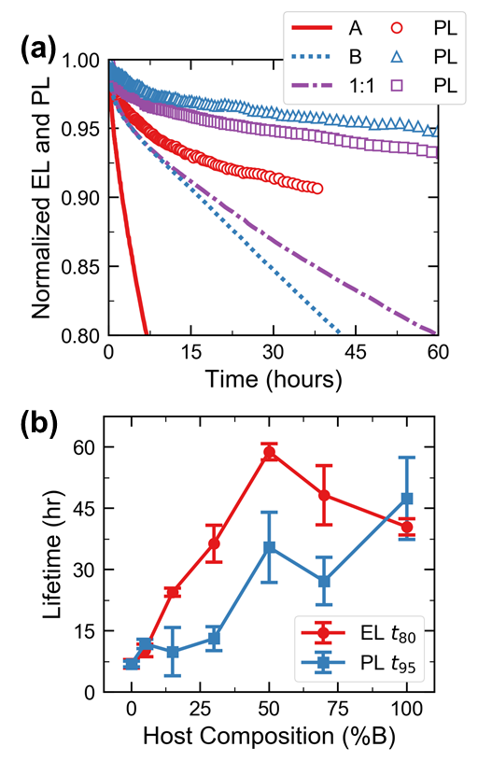

**Figure 2.** (a) Normalized electroluminescence (EL, lines) and photoluminescence (PL, symbols) lifetime curves for devices with EMLs consisting of Host A, Host B, and a 1:1 mixture of A:B. The initial luminance for all lifetimes is 5,000 cd/m2, with an operating current density of ~8 mA/cm2. (b) EL lifetime (time to reach 80% of initial value, *t80*) and PL lifetime (*t95*) as a function of host composition. EL lifetime is maximized at a host composition of 50% Host B, whereas PL lifetime is highest at a host composition of 100% Host B. Error bars represent standard deviations taken over at least four separate pixel lifetimes.

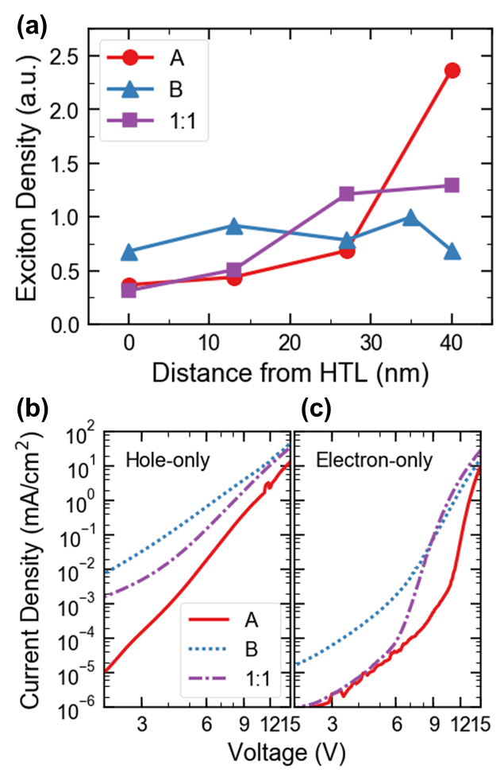

**Figure 3.** (a) Area-normalized exciton density profiles extracted from electroluminescence spectra of devices with δ-doped exciton quenching layers. The Host B device shows the broadest RZ, whereas the Host A device shows an RZ pinned at the EML/ETL interface. The 1:1 A:B mixture averages the behavior of the two neat hosts, and has less exciton density at the HTL/EML interface.

(b) Current density versus voltage for hole-only and (c) electron-only devices with EMLs consisting of Host A, Host B, and a 1:1 mixture of A:B.

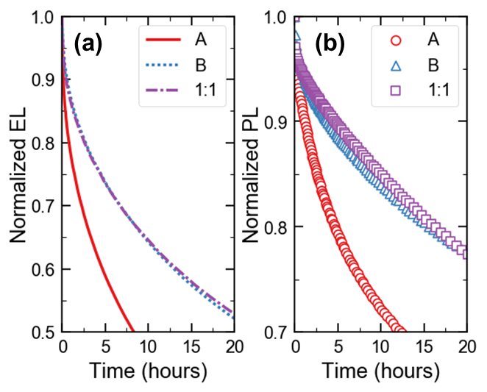

**Figure 4.** Normalized (a) EL and (b) PL for 10-nm-thick emissive layer architectures. Devices consisting of Host B and 1:1 mixtures of A and B show identical EL and PL lifetime, indicating that when differences in RZ position are eliminated, the stability of these two devices is identical.